
Ominous relict
2D Action Adventure Platformer

April 20, 2019
Wingin games studio
B,B

Contents
Summary 2
Design 4
Basics 4
Envioment 4
Characters 5
Player 5
Non-player characters (NPC’s) 5
Animations 6
Shaders 7
Sound 8
Environment sound 8
Ambient sound 8
Characters 8
Code 9
Basics 9
DiContainerInitializor 12
Data storage 12
Character 13
Player character states 14
Enemy 15
Base 15
Enemy states 15

Summary

Ominous relict is 2D adventure platformer set in the 1900-s . The story follows our main protagonist thro different parts of the world where he explores and reveals long forgotten secrets and mystic powers of the long forgotten ancient civilizations. Over the course of jurney our hero will face many difficulties and only using the right mindset and approach he will able to overcome it. Details about those difficulties and money other things will be described in this documentation.

Story

Design

Basics
The game uses 2D pixel art for environment and the characters inside of the game. Every objects and animation are drawn by hand to really catch the feeling of that old retro games Also game uses lots of shaders to really enhance the overall graphic impression of the game. Doing this we achieved strong atmospheric feeling when playing the game. Player can really feel that going thro darker parts of the temple usually will result in trouble and finding rooms filled with light usually means rewards and safety.
Envioment
In newer versions of Unity engine, development staff worked hard to improve quality of development of 2D games. That’s why Tile creation was added which improved creation and optimization of 2D environment drastically. Our environment is created using multiple 16x16 pixel arts combined into one big Tile (see picture bellow).
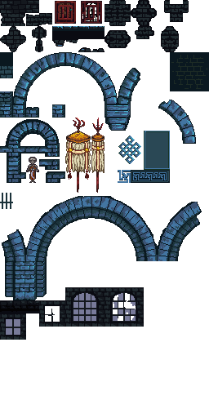
Figure 1 Temple Enviroment Tile
Characters
Player
The story is placed in the early 1900's so the character needed to reflect the look of the people that lived in that time. Main protagonist lived in the Scarborough in North Yorkshire (England) so our final redesign of the character really managed to capture the look and feed of the style that was worn in that time. On a picture bellow we can see multiple adaptation of the main character over the few game version iterations.
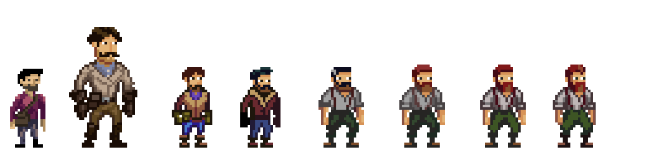

Non-player characters (NPC’s)

Because the game will take the player to different parts of the world there won’t be standard npc. For example, when you are in Mongolia in a Buddhist temple your enemy might be some ancient Monk or Shaman but when you are exploring ancient Pyramids you wouldn’t expect monk to be guarding the tomb of Pharaoh, you would expect it to be slave that was buried with the Pharaoh to guard him. Although the behaviour of the 2 might be similar or even the same giving the new design to npc will give more “realistic” approach that will also be refreshment to player. On picture bellow we can take a sneak peak in the enemies our protagonist will encounter.
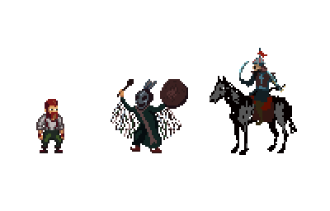

Animations
For animation our sprites we are using unity animator that is being connected directly to our animation controller engine. Core logic of the custom state controller we made forbids multiple animations to be played at the same time, because of this we got performance improvement because unity doesn’t need to calculate or tract multiple animations and transitions at the same time. We used custom start animation scheme that is perfect match for this kind of implementation. Basically, what this means is that there is one central empty state and every animation on its start and end needs to go over it. Picture bellow displays the player animator star scheme.

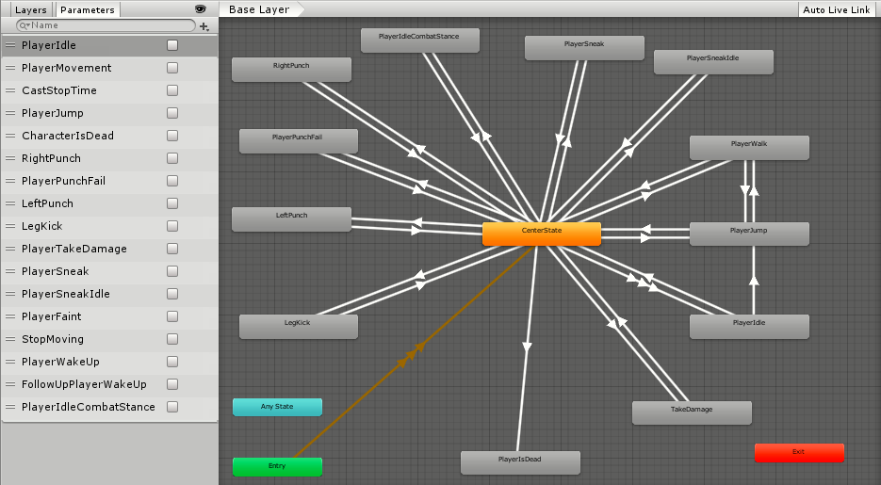
Figure 2 Player animator

Shaders
Story is based around ancient temples which means there will be a lot of dark corners of the temple and that there also needs to be some light sources for player to see where he’s heading and what he’s doing. Because of that game needed to have surface that would “react” to the light source and that’s where shaders came into the play. Without them anything inside of the game would reflect any light so quality of the atmosphere would be reduced drastically. On pictures bellow we can see, how the look of shaders for temple environment and how that same shader reflects on the in game look.
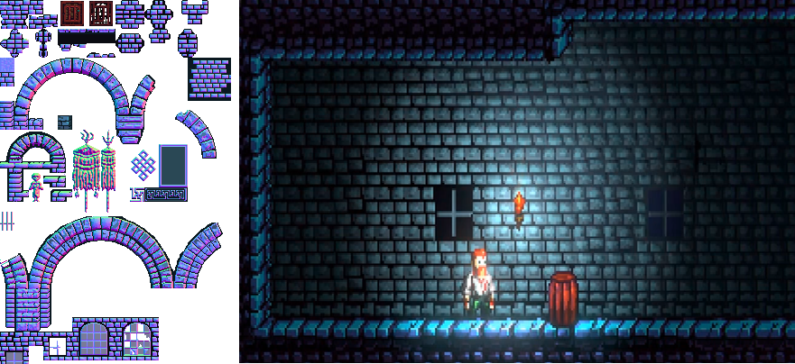
Figure 3 Shaders on left and look inside of the game on the righ

Sound
Sound in game needs to reflect the environment character is currently in. In our case it helps to signal or guide player to the hidden secrets There are few categories of the sound that will be used when creating the level.

Environment sound

Consists of all possible sounds that are strictly related to unique components such as. Platforms, breakable objects, levers, puzzles, doors, axes etc. They have limited distance at which player can hear them.
Ambient sound
Consists of sound that are playing to give a proper atmosphere while playing the game.
Characters
This sounds are distributed over the states. Every state can have zero, one or multiple sounds. For example walking consists of multiple footstep sounds because it gives more real feeling of sound.

Code
Basics
Like the design everything that is in the game was handwritten and no custom scripts were used at any point. We used custom State machine as a design pattern for the game and code bellow displays the core State script that define every state inside of the game.

namespace General.State
{
/// <summary>
/// Core state for all actions.
/// </summary>
public abstract class State : MonoBehaviour
{
/// <summary>
/// Gets or sets state priority.
/// </summary>
public int Priority { get; set; }

/// <summary>
/// Gets or sets state controller.
/// </summary>
protected StateController controller { get; set; }

/// <summary>
/// Gets or sets design controller
/// </summary>
protected DesignController designController { get; set; }

/// <summary>
/// Initializes components and parameters.
/// </summary>
protected virtual void Initialization_State()
{
DiContainerLibrary.DiContainer.DiContainerInitializor.RegisterObject(this);
designController = GetComponent<DesignController>();
controller = GetComponent<StateController>();
}

/// <summary>
/// Starts on beginning of the state.
/// </summary>
public virtual void OnEnter_State()
{
if (designController != null)
{
designController.StartTask(this);
}
}

/// <summary>
/// Checks when is the best time for state to become active.
/// </summary>
public virtual void Update_State()
{
}

/// <summary>
/// While state is active.
/// </summary>
public virtual void WhileActive_State()
{
}

/// <summary>
/// Happens when state is being swapped by other state.
/// </summary>
public virtual void OnExit_State()
{
if (this.designController != null)
{
this.designController.StopTask(this);
}
}

// Use this for initialization
void Start()
{
Initialization_State();
}

// Update is called once per frame
void Update()
{
Update_State();
}
}
}

Explanation:
State is abstract class because it is just used as a template class for other scripts that will be used in the scene. Priority of the state is a number that displays how important the state is. For example, state Idle has priority 0 and state Walk has priority 10 which means if the requirements for both states are met the Walk state will be taken as active state because it has higher priority than Idle.
State controller has a duty to control all states based on their priority and type of state. There are 3 general states inside of the game:
-State for movement: for moving objects on the scene
- State for mechanics: for doing specific work in the scene
-Higher priority state: critical states

Both state for Movement and Mechanics can be executed at the same time while in case of Higher priority state nothing else can be executed on that specific object. To make it more understandable read the following scenario:
The player is engaging in combat with enemy. While he’s hitting he is executing Player punch state which deals damage to enemy and player punch movement state which moves player a bit forward (punch force). So, he is doing movement and mechanic at the same time. Enemy was too strong for him, so player received a fatal blow and entered the higher priority state Character is dead although he was in middle of his player punch and player punch movement state.
Higher priority state doesn’t care what state player is currently in, it just knows the moment the requirements are met it needs to execute as soon as possible. Higher priority state is used only in critical moments when we don’t want any interference and objects that have only one state (Spike falling, rock rolling, platform moving etc.)
Design controller is a component that consists of two smaller controllers:
-Sound controller: controls the sound part of the object
-Animation controller: controls the animation part of the object
Both of this state can be “null” because not every object has animation or sound related to it.
Initialization_State: will be executed at very start of the every scene. It also contains custom DiContainerInitializor which will be explained in later chapters.
OnEnter_State: will be executed at the start of state activation.
Update_State: this function usually checks when requirements are met for a specific state to become active
WhileActive_state: executes while state is active.
OnExit_State: executes when state is ending or being replaced with other state.

Scenario bellow gives example of logic that state uses:
Player wants to move forward so he presses forward key. In Update_State we detect that Specific key is pressed so we call function inside of state controller with ChangeState(State newState) which check if priority is high enough for that state to become active. In case it is It calls OnEnter_State() which starts the animation and sound of that specific state. Then in function WhileActive_State() we are moving player in direction he wants as long as he moves forward key. In case he release forward key we call function inside of state controller EndState(State stateToEnd) which ends the state (if it’s the current active state equal to state we want to end) and calls OnExit_State() which stops animation and sound of that specific state.

DiContainerInitializor

It’s a custom made dependency container that allows us to instantiate objects at runtime while still preserving all information’s that we requested it. Because we are using MonoBehaviour it is not possible to perform constructor injection without the risk of runtime errors. That’s why we implemented Attribute injection. Code bellow displays example of attribute injection:
/// <summary>
/// Gets or sets player key binds;
/// </summary>
[InjectDiContainter]
protected IPlayerKeybindsData keybinds { get; set; }

Data storage

Unity engine lets us use scriptable objects as a data storage point. But again we want to have more control over what we are doing so we created custom framework that will allow use to have that extra layer of security when storing our data. All data in our database must inherit unique index interface which will assure us that every single row in table could be identified.
[DbContextConfiguration("LevelData")]
public interface ILevelData : IUniqueIndex
DbContextConfiguration defines the name of the table that data for this specific interface will be saved in. Because interface is type that just defines class not actually contains any data we need to define class that will inherit it and allow us to store data in it.
[Serializable]
public class LevelData : ILevelData

We need to point the attribute Serializable because we will convert all data into binary array that we will store as .bin file.
Example of loading and saving data:
Save - SaveAndLoadData<ILevelData>.SaveData(new LevelData());
Load - level = SaveAndLoadData<ILevelData>.LoadSpecificData("Level1");

Character
Every character consists of multiple states that limits spectrum of actions inside of scenes. Every state in scene is independent so turning it off and on should not affect the rest of states on that object. Picture bellow displays player character and its states.

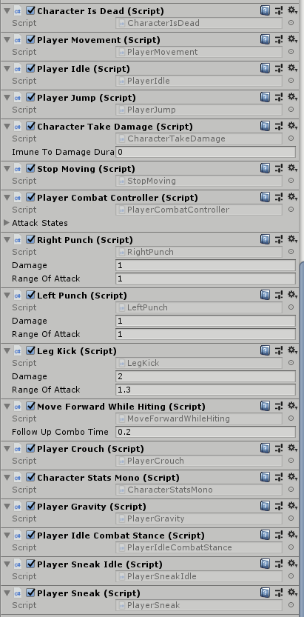
Note: Without state controller no state can become active and starting the scene with object without it would yield runtime exception.

Player character states:

State | Description | On key pressed
Movement | Player can move in left and right directions | True
Jump | Player can jump while on gorund | True
Idle | Player is idle while not doing or interacting with anything | False
Dead | If health reaches 0 player dies | False
Character take damage | Player can take damage from enemies | False
Stop moving | When main menu or Inventory is opened character should stop moving | True
Combat controller | Defines specific combo player can do | True
Left punch | Attack by left hand | True
Right punch | Attack by right hand | True
Leg kick | Attack by leg kick | True
Move forward while hitting | Moves forward while throwing punches | False
Crouch | Player crouch | True
Character Stats Mono | Holds information about character stats | False
Idle combat stance | After throwing punch if player stays on same position idle will actually be in his guard | False
Gravity | The player gravity | False
Sneak Idle | If there is wall with hole in it pressing hide key will make character hide in it | True
Player Sneak | If player is holding key he will sneak making him harder to detect | True

Enemy
Base
Enemy is npc with a task to prevent the player from completing the game. When creating enemy we need to be careful not to make it too easy or impossible to beat. Finding that middle ground is critical in overall player experience when completing the game.

Enemy states

State | Description | Core
Idle | Enemy is not doing anything | True
Detect target | If player is not hidden, in front of enemy and in range of enemy’s vision he will be detected. | True
Follow target | After enemy detected player he will start following him until he is close enough | True
Attack Target | After enemy is in close range he will start attacking player | True
Character is dead | If enemy health reaches 0 he will die | True
Attack stance | While waiting for the next attack enemy will stand in guard stance | False
Take damage | Enemy can take damage | False
Wake up | When player is walking and not sneaking by enemy that is sleeping wake up | False
Patrol | Walk between 2 points and guard area | False
Attack stance movement | The movement while in attack stance | False
Attack movement | Movement while in attack state | True
Detect target movement | Movement while detecting target | True
Character stats | Holds information about character stats | Ture

